MINUTES: BEAT 25X NCPC Meeting
Wednesday, June 12, 2013/7:00 p.m.
Redwood Heights Recreation Center/3883 Aliso Rd.

Called to order at 7:07 p.m. by Chair Bobbie Bond.

Streets represented: Tompkins, Daisy, Davenport, Anderson, Wilkie, Jordan Road, Mattis Court, Maybelle and Fair.

Announcements:
- Nixle is a good tool to use to know what is occurring with OPD and other City departments. Go to www.nixle.com to register.
- Laurel Village Association meeting June 27, 2013/6:30 p.m., World Ground Café. National Night Out, August 6th. Visit www2.oaklandnet.com/nno to register a party.
- Laurel Street Fair (sponsored by Laurel Merchants), Saturday, August 10th
- Businesses coming soon to the Laurel: martial arts gear, shoe store, pre-school, Goodwill, yoga studio and a portable electronics repair shop.
- Residents were asked to complete a Measure Y survey. This gauges the community’s familiarity with the PSO and NCPCs.

New Beat 25X Problem Solving Officer (PSO), Sean Festag.
- The department is down approximately 200-300 sworn officers.
- The biggest advantage of Measure Y is that it ensures specific officers are assigned to specific areas. In regards to the PSOs, their primary duty is to work on police issues and projects within their assigned beat.
- Festag chooses to focus on problems that are brought to his attention. This is a “luxury” that non-PSO officers do not have who must constantly respond to calls. “He doesn’t have to be a slave to his radio.”
- Festag works closely with Neighborhood Services Coordinator (NSC), Renee Sykes. With her referring people to other City services, it frees up more time for him to pursue beat projects.
- Currently, he and other officers are working mandatory overtime. Many officers are tired and leaving for jurisdictions where there are enough officers and no mandated overtime.
- Q. How can we get more police on the streets? A.The City is working on hiring more officers by having several police academies in the next two years. One academy class is scheduled to graduate in July, another one in September.
- Current staffing prevents officers from working proactively in neighborhoods.
- Q. Haven’t there been two academies? A. Yes, but it takes a while before officers can be released on their own. Attrition among current officers also means the department can end up just treading water.
- A neighbor stated those present need to contact their Council members immediately and state they want police in the budget before any other services.
- Update: Great police work was done today. A robbery occurred on Madrone on Tuesday where two construction workers were mugged. A neighbor was able to obtain a photo of the suspects which he provided to the police officers who responded to the call. Festag was able to download the photos immediately. Shortly thereafter, Festag responded to another call where an officer had detained one of the robbers and was unfamiliar with the Madrone incident. This morning, the same two officers from yesterday saw the van, stopped it and found stolen property inside the van. The pair may be responsible for several robberies and burglaries in the area. Neighbor participation/nosiness made the difference. Keep helping them catch criminals. 9-1-1 from a cell phone is : 777.3211 or call the non-emergency number at 777-3333.
- NSC Sykes stated that even if residents believe the police are not responding to everything, every time, don’t stop calling; it makes a big difference.
- House on Maybelle. A neighbor reported to the Drug Hotline there was drug activity at a house nearby. It’s important to call the DHL line every time as well if residents suspect drug activity. OPD needs solid, documented information from citizens. Call, file reports. Don’t just talk about it to other neighbors.
- Festag: if there are more cops—even sitting in their cars—we’d be safer.
- Q. Are all the police officers ready to “rock and roll” actually out on the street? A. No. Those behind the desks are not available.
- With Sideshow activity returning, the City has passed an ordinance preventing the police from confiscating sides show cars. This reduces OPD’s ability to control Side Show activity.
- Q. We have the most expensive police in the area (per policeman). A. 10 years ago OPD paid high salaries in order to attract experienced urban police officers. The risks are even higher now.
- Q. If we keep addressing the City Council can we make a change? A. Yes, but different people have to come and speak out at Council meetings.
- Q. Do we have a permanent Beat Officer for 25X? A. Unclear.
- Q. Do large apartment buildings bring more problems to a community? A. Not necessarily. Sykes stated action is needed from neighbors. Vigilance is required. Sykes related a story of staying vigilant—calling, paying attention, documenting, etc….

Officer Elections (Chair, Co-chair, Parliamentarian, Secretary). Individuals seeking an officer position were asked to be prepared to share what contributions they have made to improve the NCPC and/or their community. A motion was made from the floor to keep the current officers in position.
- Current officers were unanimously re-elected.

Community Concerns
- Safeway remodeling at Lincoln Square
- Council meeting Thursday June 13, 2013/ 4:30 p.m. Budget hearing
- 4331 Tompkins-an eviction occurred; the problems should go away.
- A property on Daisy St and a house on Buell St. may be connected in regards to drug activity. Both pieces of property are owned by two brothers. One is in jail and in the past allowed his friends to come in and squat. (This has been occurring at the property on Daisy St.). The other brother has been very helpful and working with the police and other city agencies. Does any resident know of drug activity occurring in the 3800 block of Buell St? Please call the drug hotline at 238-DRUG.
- Q. Neighbor stated the folks on Daisy St. are listening to calls. Can OPD use other terminology for the property so as not to tip them off? A. non-responsive.
- Safeway has purchased the Lincoln Square property. City Planner says application has been submitted for remodel. There is no application before the City for developing the entire site.
- 4690 Tompkins (Beulah Home). Rob Brackett made a presentation in which the following points were addressed:

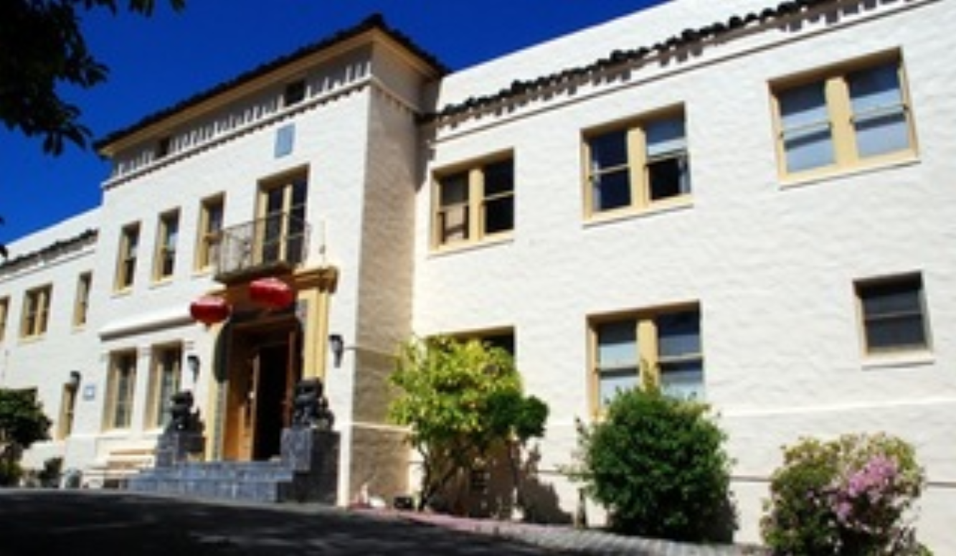
The Beulah Home at 4690 Tompkins, Oakland CA must remain dedicated to what it’s always been—a home for the community’s elderly.
There’s more than a 100-year neighborhood tradition of having an elder care facility (starting with the Home for Aged and Infirmed Colored People founded in 1897 by the California Association of Colored Women’s Clubs) in our neighborhood. More than 60 years ago, the building currently at 4690 Tompkins was built by the Methodist Church as a senior living community

So what’s the problem?
Urban Green Investments (owners of the “Ridge Hotel” in Oakland with more than 400 "911” crime calls in 2012) purchased Beulah Home in a bankruptcy sale. Instead of keeping it as a senior residence and care facility, they have applied to the City to convert Beulah Home from one of Oakland’s oldest senior residence and care facilities to 40 ± 650 sq./ft. apartments.

The proposed design submitted by Urban Green is an attempt to subvert the original intention of the Commission and City Council’s most recent zoning plan. The City gave special zoning considerations so that 4690 Tompkins, as a senior living and care facility, could continue to be part of our neighborhood. Now Urban Green hopes that the Planning Commission and Council will ignore the fact that their design plan is not for a high-density, low impact senior facility but instead for a 40 unit apartment building, eight additional rental units along with issues pertaining to noise, traffic, and other environmental impacts such as massive development.

Can Oakland really afford to reduce its stock of housing for Seniors?
The U.S. population for individuals age 65 and older is expected to more than double between 2012 and 2060, from 43.1 million to 92.0 million (U.S. Census Bureau). Oakland needs more elder housing not less—especially when our city’s senior population and their need for specialized residential care will only increase.

Can Oakland really afford to allow conversion of a senior facility that will employ dozens of Oaklanders to apartments that will produce few jobs?
Elder housing and care requires qualified staff on-site. That means jobs for people and spending for local businesses.
Can a neighborhood largely comprised of single-family homes (RD-1) absorb the impact of a 40-unit apartment house?
Currently, there are no apartment houses of more than 6 units in any of the surrounding neighborhoods bounded by MacArthur & Highway 13 (east/west) and Calaveras and the south side of High Street (north/south). Many of the proposed apartments’ renters will be driving in and out multiple times each day to work, run errands, etc. Other renters and their guests will choose to park on already congested streets in order to be closer to their apartments.

Our Objective: To continue the neighborhood-appropriate use of 4690 Tompkins as a senior living community, while respecting the investment of Urban Green/Cornerstone Holdings LLC.

What can be done now to help the neighborhood? (Time is of the essence)!
- Sign the letter saying “no” to the conversion of Beulah Home to apartments and “yes” to keeping it a seniors’ residential home. Contact: Barbara Lanier (barbalanier@gmail.com)

- Write a “no apartment house conversion” letter/email today to the:
- Oakland City Planning Commissioners patillo@pgadesigns.com, jaw1123@aol.com, jahazielbonillaoaklandpc@gmail.com, michael@mbcarch.com, jmoore.ocpc@gmail.com, ew.oakland@gmail.com
- City Planner, Aubrey Rose arose@oaklandnet.com
- Members of the Oakland City Council council@oaklandnet.com
- Mayor Jean Quan at jquan@oaklandnet.com and City Administrator Deanna Santana at dsantana@oaklandnet.com

- Get on the email list and join as a volunteer. (wendy_auyoung@hotmail.com).

- Pass this information on to other neighbors. More copies? Contact: (wendy_auyoung@hotmail.com).

- Show up at public meetings. Bring a sign. Make a speech

- Make a donation to help pay legal research and representation costs. Contact: Barbara Lanier barbalanier@gmail.com or Maria Scog mscog750@icloud.com (Co-treasurers). Any funds not spent for related legal costs will be returned (proportionally) to donors.

- Lily, Tulip, Madrone Streets-it has been difficult in the past to organize Neighborhood Watch (NW) groups on these streets. The three motels nearby are rumored to have prostitution activity occurring. Allegedly this activity is impacting surrounding neighborhoods. If residents observe prostitution activity, they should call the prostitution hotline at (510) 238-2373.
- NCPC Priorities (4800 block of Daisy St and 3800 block of Buell St).

Meeting adjourned at 8:30 pm by Chair Bond

Respectfully submitted,

Danny Cieloha, Secretary
NCPC Beat 25X

